Pheno Seal®
Thank you for visiting the FORTA Drilling Division Website and specifically Pheno Seal. Please take a few minutes to get acquainted with FORTA® Pheno Seal® and our other drilling products.
GENERAL INFORMATION AND ADVANTAGES
Pheno Seal® is a chemically stable thermoset laminate used for lost circulation, bit balling, and pipe and casing sliding in all water, oil, and synthetic based fluids and cements. The original laminate sheets are ground into flakes and sized to provide maximum sealability using minimum pounds per barrel. Pheno Seal® is safe and effective in all water, oil, and synthetic-based muds, and is also compatible with squeezes and cements. Pheno Seal® is one of the most effective loss circulation materials on the market, offering tremendous performance advantages in cases of fractured formations, seepage loss, and bit balling.
Fractured Formations  Each hard chip shaped Pheno Seal® particle hydraulically rotates with the fluid and flows into fractures along the wellbore. As the particles wedge together inside the fracture, the differential pressure wedges the particles tighter together, which in turn increases the pressure resistance of the seal. Pheno Seal®, in high concentrations, is an effective squeeze material. Pheno Seal's optimum particle shape and sizing provides quicker and more complete seals than blended materials. | 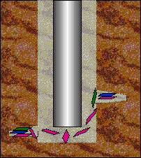
 | Pheno Seal® Sealing Fractures
Seepage Loss, Pipe Sliding and Running Casing  Pheno Seal® provides a hard, smooth, pressure resistant barrier between the drillstring and wellbore. This reduces the pressure differential along the wellbore, as well as reducing the adhesion between the drillpipe and filtercake. Pheno Seal® and calcium carbonate is preferred. Unlike granular materials, Pheno Seal® does not degrade filtercake quality. | 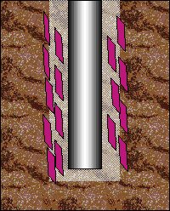
 | Pheno Seal® Provides a Hard, Smooth Barrier
Bit Balling
The strong, thin edges of each Pheno Seal® particle cut away at formation build-up on bits and stabilizers like a knife blade. Pheno Seal® also contains approximately 7 times more particles per pound than nut plug. Pheno Seal's inherent hardness, multiple cutting edges, and optimum hydraulic shape allow for an effective and economical solution for controlling formation buildup on bits and stabilizers.
MWD, Down Hole Tools, and Mud Motors
The maximum particle size of Pheno Seal® Fine is smaller than nut hulls medium. Pheno Seal® Fine can be used in tools and mud motors that have approved the use of medium nut hulls. Any screens used in the drill pipe should be kept at the surface, and not placed down hole. Typical Pheno Seal® particle sizing is listed in the chart below, along with a recommended minimum jet size for the the various Pheno Seal® gradations.
Typical Pheno Seal→ Particle Sizing -- (% Retained)
MESH | MICRON | FINE | MEDIUM | COARSE
-80  +80  +60  +20  +14  +10  +4 | 177  177  250  850  1190  2000  4750 | 1.6  4.0  44.9  20.6  28.9  0.0  0.0 | 0.0  0.0  0.1  0.2  25.4  74.3  0.0 | 0.0  0.0  0.0  0.2  12.4  82.2  5.2
Minimum Jet Size None 9/32 16/32

Pheno Seal® Advantages  - Best cost to benefit ratio of any LCM product.  - Outperforms nutshells, fibers, mica, and blended materials for sealing fractures.  - 7 times more particles per pound than granular LCM products, including nut hulls.  - Approximately 50% more usable material per pound than mica.  - No adverse effect on LC50 values.  - Temperature stable to 500 F in all fluids  - Does not weaken or deteriorate during use.  - Chemically inert.  - Compatible with all water, oil, and synthetic based drilling fluids. | 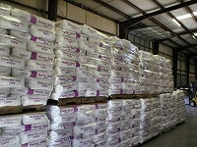  Pheno Seal®

